Narrative # 1
Concert:
Soave Sia Il Vento
With artists:
Radio Kamerorkest
Sante, Sophia van
Berg, Maurits van den
Ameling, Elly
Derksen, Jan
With creator(s):
Mozart, Wolfgang Amadeus
Has genre:
klassieke muziek
theatermuziek
vocaal - twee of meer zangstemmen met orkest
The most important entity seems to be Mozart, Wolfgang Amadeus which was also was part of:
Concert:
Programma Radio Kamerorkest - Nederlands Kamerorkest - Bour, Ernest - Vries, Han de - Werthen, Rudolf - Quant, Abbie de - Meyer, Hans
With artists:
Radio Kamerorkest
Nederlands Kamerorkest
Bour, Ernest
Quant, Abbie de
Vries, Han de (musicus)
Werthen, Rudolf
Meyer, Hans
With creator(s):
Mozart, Wolfgang Amadeus
Salieri, Antonio
Mysliveček, Josef
Year of publication:
1984
Location it was created:
Amsterdam
Provider organization:
VOO
The most important entity seems to be Radio Kamerorkest which was also was part of:
Concert:
Programma Radio Kamerorkest - Carewe, John
With artists:
Radio Kamerorkest
Year of publication:
1984
Has genre:
klassieke muziek
instrumentaal - orkest
Provider organization:
NCRV
The most important entity seems to be 1984 which was also was part of:
Concert:
Programma Concertgebouworkest - Haitink, Bernard - Brautigam, Ronald
With artists:
Concertgebouworkest
Haitink, Bernard
Brautigam, Ronald
With creator(s):
Mozart, Wolfgang Amadeus
Beethoven, Ludwig van
Prokofjev, Sergei
Year of publication:
1984
Location it was created:
Amsterdam
Provider organization:
WERELDOMROEP
The most important entity seems to be Amsterdam

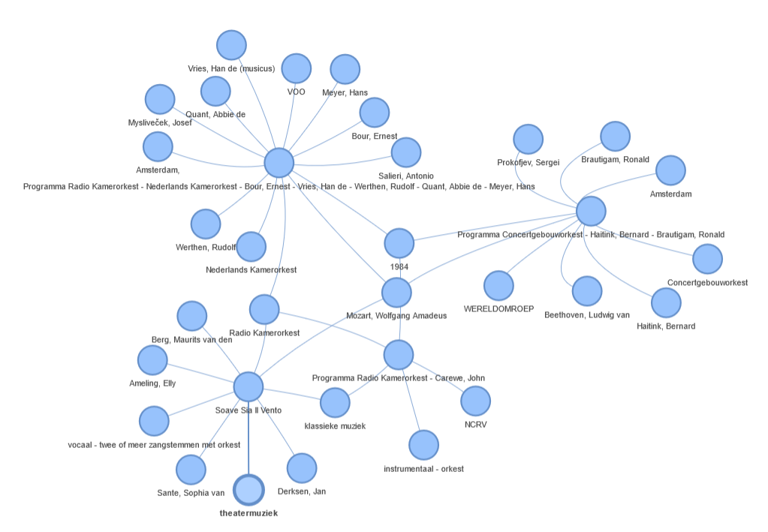
Fig 4.3.2: Narrative # 1 Visualization
Narrative #2
Concert:
Programma Radio Kamerorkest - Koopman, Ton
With artists:
Koopman, Ton
Radio Kamerorkest
Year of publication:
1984
Has genre:
klassieke muziek
religieuze muziek
instrumentaal - orkest
Location it was created:
Amsterdam
Provider organization:
VARA
The most important entity seems to be instrumentaal - orkest which was also was part of:
Concert:
Programma Radio Kamerorkest - Carewe, John
With artists:
Radio Kamerorkest
Year of publication:
1984
Has genre:
klassieke muziek
instrumentaal - orkest
Location it was created:
Amsterdam
Provider organization:
VPRO
The most important entity seems to be VPRO which was also was part of:
Concert:
Programma Radio Kamerorkest - Carewe, John
With artists:
Radio Kamerorkest
Year of publication:
1984
Has genre:
klassieke muziek
instrumentaal - orkest
Provider organization:
VPRO
The most important entity seems to be Radio Kamerorkest which was also was part of:
Concert:
Programma Radio Kamerorkest - Zender, Hans
With artists:
Radio Kamerorkest
Zender, Hans
Year of publication:
1984
Has genre:
klassieke muziek
instrumentaal - orkest
Provider organization:
NCRV
The most important entity seems to be Zender, Hans

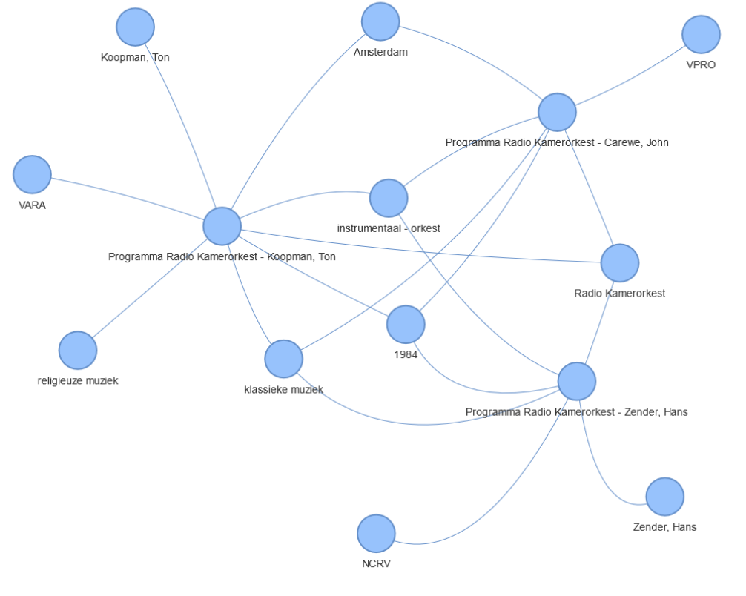
Fig 4.3.3: Narrative # 2 Visualization
Narrative # 3
Concert:
Mis in C gr.t. (KV.317)
With artists:
Koopman, Ton
Radio Kamerorkest
Groot Omroepkoor
Mertens, Klaus
Magnus, Elisabeth von
Trost, Rainer
Rey, Isabel
With creator(s):
Mozart, Wolfgang Amadeus
Has genre:
klassieke muziek
religieuze muziek
vocaal - solo of soli met koor en orkest
Location it was created:
Amsterdam
The most important entity seems to be Groot Omroepkoor which was also was part of:
Concert:
Programma Frimmer, Monika - Dykstra, Hebe - Berne, Harry van - Heynsbergen, Henk van - Vera, Ana Maria - Groot Omroepkoor - Radio Kamerorkest - Oestman, Arnold
With artists:
Radio Kamerorkest
Groot Omroepkoor
Oestman, Arnold
Heijnsbergen, Henk van
Dijkstra, Hebe
Berne, Harry van
Vera, Ana Maria
Frimmer, Monika
With creator(s):
Mozart, Wolfgang Amadeus
Year of publication:
1991
Location it was created:
AT&
Provider organization:
NCRV
The most important entity seems to be Oestman, Arnold which was also was part of:
Concert:
Fluit-harpconcert in C gr.t. (KV.299)
With artists:
Radio Kamerorkest
Quant, Abbie de
Smits, Manja
Oestman, Arnold
With creator(s):
Mozart, Wolfgang Amadeus
Has genre:
klassieke muziek
instrumentaal - orkest
Location it was created:
Amsterdam
The most important entity seems to be Quant, Abbie de which was also was part of:
Concert:
Fluit-harpconcert in C gr.t. (KV.299)
With artists:
Radio Kamerorkest
Kieft, Roland
Witsenburg, Edward
Quant, Abbie de
With creator(s):
Mozart, Wolfgang Amadeus
Has genre:
klassieke muziek
instrumentaal - orkest
Location it was created:
Utrecht
The most important entity seems to be Kieft, Roland

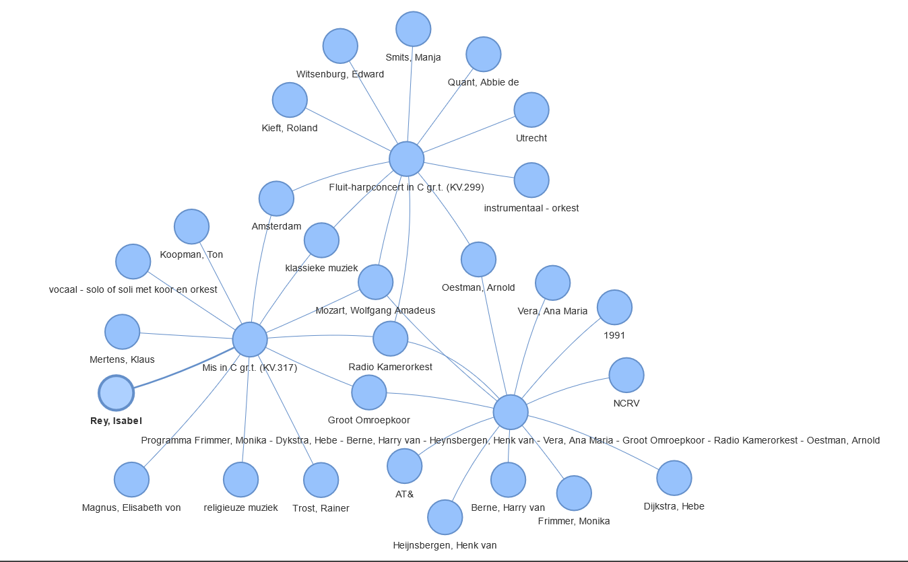
Fig 4.3.4: Narrative # 3 Visualization
Narrative # 4
Concert :
Programma Blochwitz, Hans Peter - Mills, Erie - Montgomery, Kenneth - Montgomery, Kenneth - Pierotti, Raquel - Gale, Elisabeth - Vink, Elena - Meens, Hein - Omroep Kamerkoor - Klein Omroepkoor - Gritton, Robin - Radio Kamerorkest
With artists:
Radio Kamerorkest
Omroep Kamerkoor
Montgomery, Kenneth
Klein Omroepkoor
Meens, Hein
Gritton, Robin
Mills, Erie
Pierotti, Raquel
Blochwitz, Hans Peter
Vink, Elena
Gale, Elisabeth
Year of publication:
1984
Has genre:
klassieke muziek
vocaal - solo of soli met koor en orkest
theatermuziek
Location it was created:
Amsterdam
Provider organization:
WERELDOMROEP
VARA
The most important entity seems to be Montgomery, Kenneth which was also was part of:
Concert:
Programma Koten, Frank van - Jeurissen, Herman - Lier, Sonja van - Nyhuis, Annelies - Robert, Geraint - Groot Omroepkoor - Radio Kamerorkest - Montgomery, Kenneth
With artists:
Radio Kamerorkest
Groot Omroepkoor
Montgomery, Kenneth
Lier, Sonja van
Koten, Frank van
Jeurissen, Herman
With creator(s):
Mozart, Wolfgang Amadeus
Haydn, Joseph
Bree, Johannes van
Year of publication:
1990
Location it was created:
VARA
Provider organization:
NCRV
The most important entity seems to be Haydn, Joseph which was also was part of:
Concert:
Programma Rotterdams Ph.Orkest - Conlon, James - Merwe Hoorn, Martin v.d.
With artists:
Rotterdams Philharmonisch Orkest
Conlon, James
With creator(s):
Mozart, Wolfgang Amadeus
Haydn, Joseph
Gluck, Christoph Willibald von
Year of publication:
1984
Location it was created:
De
Provider organization:
NOS
The most important entity seems to be Gluck, Christoph Willibald von which was also was part of:
Concert:
Programma Bommel Kwartet - Bilitis Ensemble
With artists:
Bommelkwartet
With creator(s):
Telemann, Georg Philipp
Haydn, Joseph
Berlioz, Hector
Jolivet, André
Saint-Saëns, Camille
Falla, Manuel de
Bruch, Max
Gluck, Christoph Willibald von
Meijering, Chiel
Paganini, Niccolò
Zelenka, Jan Dismas
Year of publication:
1984
Location it was created:
VARA
Provider organization:
VOO
The most important entity seems to be Telemann, Georg

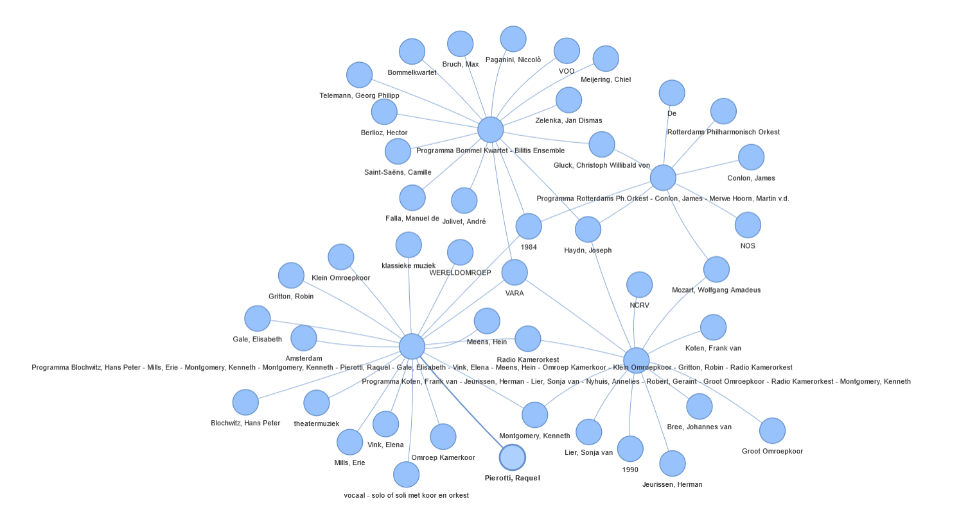
Fig 4.3.5: Narrative # 4 Visualization
Narrative # 5
Concert:
Vioolconcert No.4 In D Gr.t. (kv.218)
With artists:
Radio Kamerorkest
Driehuys, Leo
Bor, Christiaan
With creator(s):
Mozart, Wolfgang Amadeus
Has genre:
klassieke muziek
instrumentaal - orkest
The most important entity seems to be Driehuys, Leo which was also was part of:
Concert:
Pianoconcert No.19 In F Gr.t. (kv.459)
With artists:
Radio Kamerorkest
Driehuys, Leo
Andersen, Diane
With creator(s):
Mozart, Wolfgang Amadeus
Has genre:
klassieke muziek
instrumentaal - orkest
The most important entity seems to be Andersen, Diane which was also was part of:
Concert:
Programma Andersen, Diane - Radio Filh.Orkest - Fournet, Jean
With artists:
Fournet, Jean
Andersen, Diane
With creator(s):
Schoonhoven, Frank
Year of publication:
1986
Has genre:
klassieke muziek
instrumentaal - orkest
Provider organization:
NCRV
The most important entity seems to be Fournet, Jean which was also was part of:
Concert:
Ouverture
With artists:
Radio Kamerorkest
Fournet, Jean
With creator(s):
Mozart, Wolfgang Amadeus
Has genre:
klassieke muziek
theatermuziek
instrumentaal - orkest
Location it was created:
Amsterdam
The most important entity seems to be theatermuziek

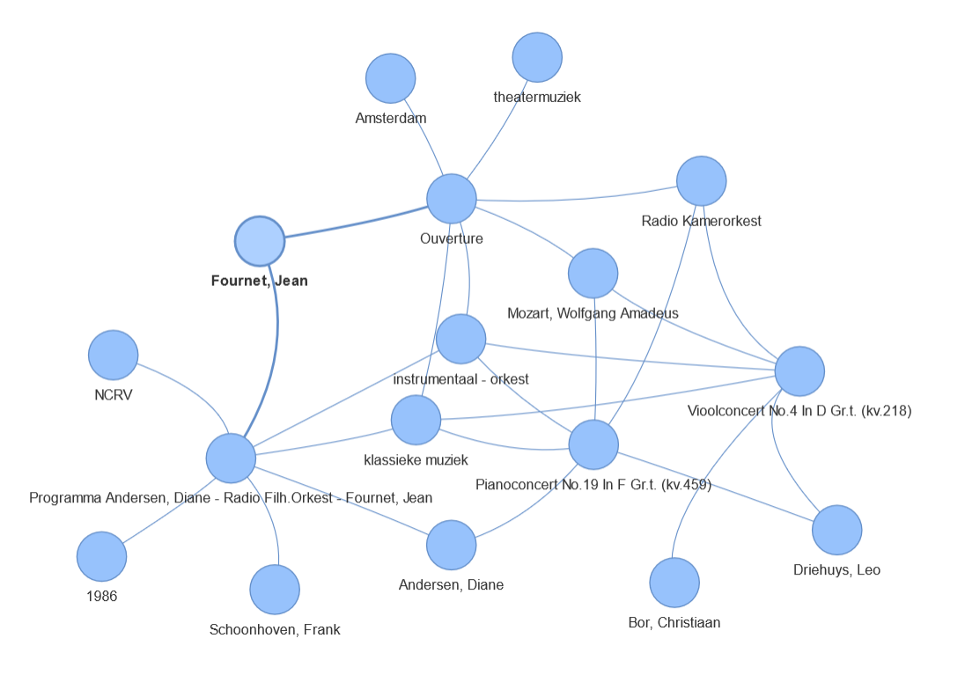
Fig 4.3.6: Narrative # 5 Visualization

